Field lab: Alternative methods for terminating cover crops

Final report, 2018
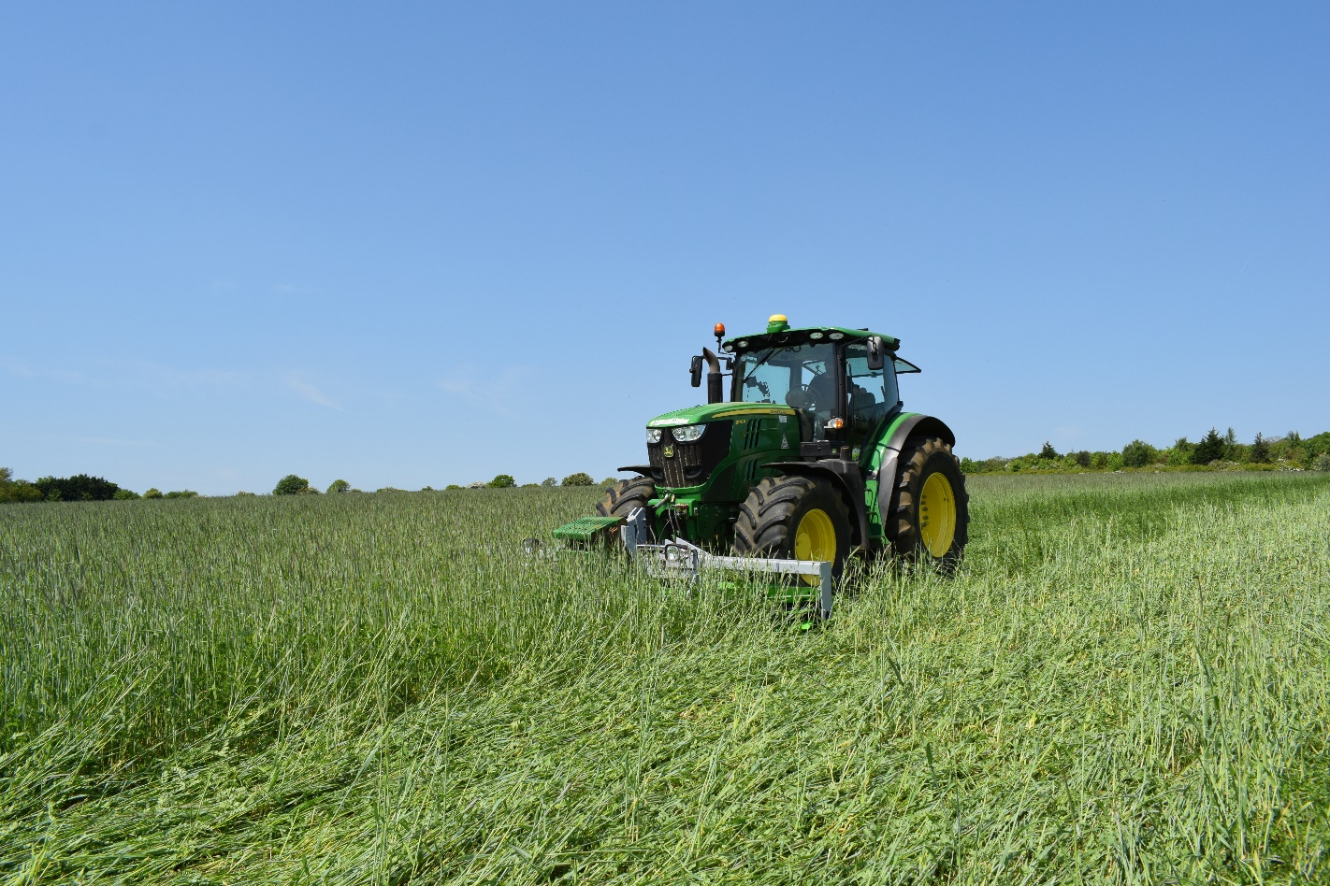

Authors:
Liz Bowles, Soil Association
Helen Holmes, ADAS

Summary
This field lab conducted and analysed farm-scale trials on alternative methods to glyphosate for cover crop destruction on organic and non-organic farms. A range of different methods of terminating cover crops were investigated in order to reduce reliance on herbicides such as glyphosate.
At the first meeting over 20 farmers convened at Shimpling Park Farm, Suffolk to discuss how to address the challenge of terminating cover crops without the use of glyphosate. After a farm walk and a presentation about different cover crop mix performance the group discussed the research question they would like to address and agreed who would be involved with on farm testing. In total six farmers and seven field sites agreed to be involved and of these, two of the sites were organic. The field sites were located in Cambridgeshire, Suffolk, Norfolk and Oxfordshire.
The key research question the group identified was “what is the impact of different cover crop termination methods on the yield of the following crop”.
The group agreed the following steps to the field lab:
- Selection of species mix
- Overwintering of the cover crop (e.g. rye and vetch)
- Killing off the cover crop using one of the following methods:
- frost
- shallow non –inversion tillage
- rolling
- crimper-rolling*
- Direct drilling the following crop into the dead mulch
The approach included designing a species mix which would be effectively killed by frost, shallow non –inversion tillage, rolling and crimper-rolling. The overwintering cover crops (e.g. rye and vetch) were killed off and laid flat by rolling when the crops were flowering.
* The crimper-roller method involved using equipment that has been developed in Italy and at the Rodale Institute (Forcella, 2014).
Outcomes of the trials included:
- examples of different cover crop species or mixes grown on different soil types
- a measure of the how effective different cultivation methods were on cover crop termination at these sites (where possible the researchers were able to test for statistical significance of results).
This field lab has been encouraging in that no negative impacts on following crop establishment were found from the range of cover crop termination methods used on the three sites. However, more field trials are required to better understand the efficacy of different termination methods in different situations.

1 Field lab aims
The aim of this field lab is to test the efficacy of alternative methods to terminate cover crops in order to reduce herbicide inputs. This would be beneficial for managing herbicide resistance and allow organic and non-organic farms to control weeds more sustainably and possibly improve soil health.
2 Background
Sustainable farming aims to produce food without using unsustainable external inputs while conserving soil health. However, reduced and minimum tillage cultivation systems, which reduce damage to soil structure, have been difficult to implement in organic systems where ploughing is the primary method of control for many weed species (Holland, 2004). Cover crops and living mulches, which are often used to build organic matter and suppress weeds between main crops in rotations, are a key component of conservation agriculture which will enable reduced soil disturbance in organic systems. Reduced tillage systems have been more readily achievable in non-organic systems but rely heavily on the use of herbicides such as glyphosate to control weeds and terminate cover crops. There is some concern over the future availability of glyphosate, and careful use of glyphosate is needed for resistance management (Case, 2017). The discovery of alternative methods to terminate cover crops is becoming ever more important.
This field lab gave the farmers involved a chance to explore cover crop termination methods other than glyphosate and evaluate the success of these methods in a farm scale replicated trial analysed by the researchers, ADAS. This provided valuable examples of cover crop agronomy that are beneficial to soil structure and the environment and may well be relied on in a future where glyphosate may be unavailable.
3 Methodology and data collection
At a first meeting over 20 farmer convened at Shimpling Park Farm, Suffolk to discuss how to address this challenge. After a farm walk and a presentation about different cover crop mix performance the group discussed the research question they would like to address and agreed who would be involved with on farm testing.
The group agreed that their key research question was to identify the impact on the yield of the following crop of a range of different cover crop termination methods.
In total 6 farmers and seven field sites agreed to be involved of which two sites were organic. Field sites were in Cambridgeshire, Suffolk, Norfolk and Oxfordshire.
The tramline trials used the farmers’ own equipment to treat and harvest the trials. The layout included up to three treatments per site plus a control (Glyphosate or usual farm cultivations for organic growers). The treatments were replicated to be statistically robust enough to establish any significant treatment effects.
Trial plots on the seven sites were established according to the template below.
Farm triallists were responsible for drilling cover crops, with seeds donated by Kings Crops.

Mix A | Oil radish, spring oats
Mix B | Phacelia, mustard, berseem clover, buckwheat

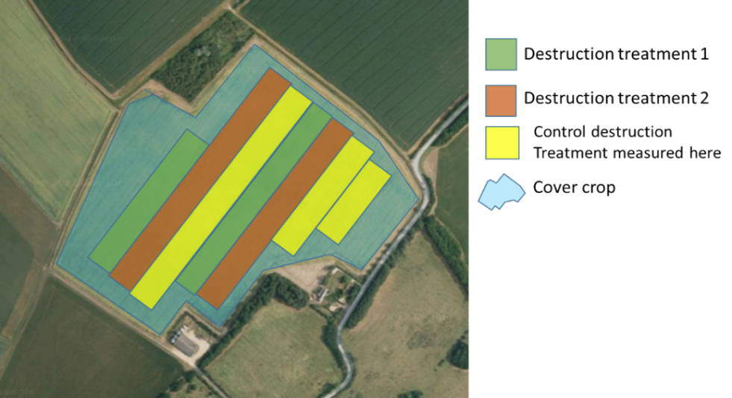
This report summarises the results from 3 growers with the most comprehensive sets of data collected.

Trial design: Farmer A
Farmer A tested 2 designs in 2 adjacent fields.
Field 1: Farmer A tested 2 methods (flail or roll) for destruction of a bespoke field beans and phacelia cover crop mix as per below:
Field 2: Farmer A applied a design where 4 destruction methods were applied at right angles to 4 cover crops giving 16 treatment plots (See diagram below). Destruction methods were: A – Rolled once; B – Rolled twice; C – Flailed (25 November); and D – Crimped (9 December). After cover crop destruction a crop of spring barley was established.
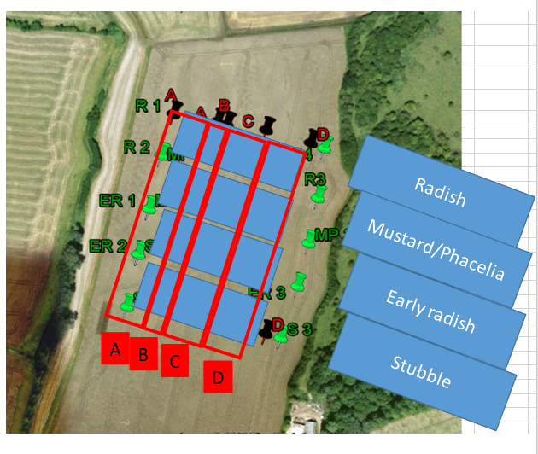

Trial design: Farmer B
Farmer B split their field and established cover crop Mix A in one half and Mix B in the other. Within each half, the farmer applied destruction treatments Glyphosate and Liquid N fertiliser to alternate tramlines to give maximum replication. The fertiliser treatment was also sprayed off with Glyphosate for 100% kill. All strips the same total amount of N fertiliser. The destruction treatments were applied on 5th April with a following linseed crop established on 8th May.
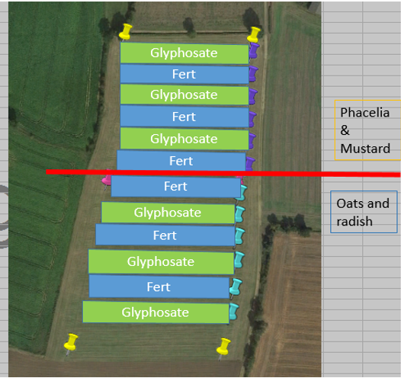

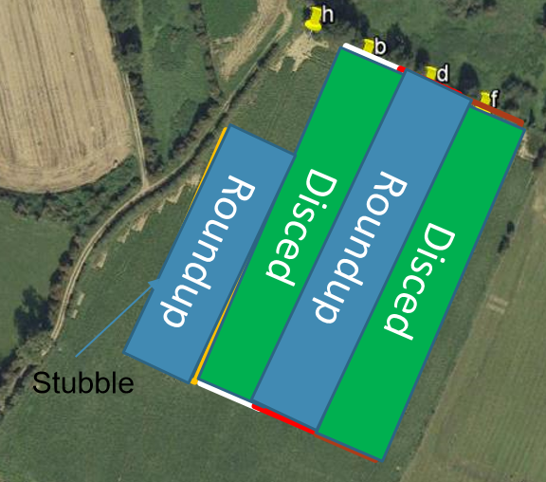
Trial design: Farmer C
Farmer C tested cover crop mix A only with the destruction treatments of roundup (Glyphosate) and discing. After destruction, maize was drilled on 25th May.

Farm triallists set up their trial plots using GPS and other IT aids where available. The monitoring that was carried out is set out below together with responsibilities as agreed between the farm triallists and the researcher.

Stage | Monitoring requirement | Trial hosts | ADAS
Cover crop establishment | Plant population/m², weed, pest disease problems | x
Pre-termination on termination day | Measurement of cover crop height, taking overhead photographs of at least 1 square metre of cover for green area index (GAI) assessment | x
Post termination | Weekly photographs from the same place in each treatment (a cane/post was used to mark the photograph location).  A quadrat e.g. 1m² or piece of A4 paper laid on the field and included in the photograph to give an idea of scale. | x
Cash crop establishment | Plant population at full establishment, assessments for weeds, pests and diseases by ADAS.  Photographs or observations through season recorded by trial hosts | x | x
Harvest | Using a yield mapping combine the quality of the yield data was crucial for the trial. To maximise the quality of the data trial hosts were asked to  - CALIBRATE the combine according to the manufacturer’s instructions and ensuring the yield mapping function is working correctly.  - Keep HARVEST DIRECTION closely in line with the tramlines. Headlands can be cut separately, but for the body of the field transverse or even slightly oblique harvesting is unfortunately not acceptable.  - Harvest FULL HEADER WIDTHS wherever possible.  - Harvest WITHIN ONE TREATMENT area, i.e. avoid having the header spanning two treatment areas.  - Harvest the whole field with the SAME COMBINE and on the SAME DAY | x

NDVI assessments
Where possible, satellite imagery was obtained for each field. This uses a multispectral camera to collect data on the amounts of different wavelengths (visible and non-visible) of light that were reflected from the crop. The light reflected at certain wavelengths can be used to calculate vegetation indices, including NDVI (Normalised Difference Vegetation Index), which indicates canopy differences. A higher number is associated with a thicker crop.
Samplings and assessments
- Soil samples: taken by farm triallists and sent for analysis at NRM laboratories at key points throughout the growing season, to provide data on soil pH, moisture and water retention capacity, SOM, cation exchange capacity and infiltration rate
- Cover crop establishment: assessments were made by the farm triallists, including plant population/m², weed, pest disease problems
- Cover crop height: assessments made pre-termination by farm triallists, taking overhead photographs of at least 1 square metre of cover for GAI assessment
- Treatment effectiveness: assessed post termination by farm triallists, determined through photography
- Plant population: assessed for weeds, pests and diseases by ADAS at full establishment. Photographs or observations through season recorded by trial hosts.
- Yield data: The trial layout allowed the plots to be combined by commercial farm equipment that could provide combine yield data. However, due to the hot, dry summer, and early harvest affecting crops, yield data were only available from one site.
Harvest
The exact approach depended on the relative widths of the treatment areas and the combine used. Where possible two swathes were cut in each treatment area, one on either side of the wheeling, such that in both cases the combine header was full and all within the same treatment, and did not include the wheeling (see right). Any remaining crop was cleared up afterwards.
Raw yield mapping data for the whole field was sent to the researchers (usually a .csv or .aft file).
4 Results and discussions
The table below sets out the cropping for the triallists with the most complete dataset together with information on cover crop drilling and termination dates. For these farmers, tiller establishment of the cash crop was measured for control and treatments as well as Normalized Difference Vegetation Index or NDVI maps to assess vegetation.
Farmer | Cover crop used | Drilling date of cover crop | Termination of cover crop date | Termination methods | Drilling date for cash crop | Cash crop
Farmer A | Field 1: Field beans & phacelia  Field 2: 4 different cover crops – radish, mustard/phacelia, early radish, stubble | Early autumn | 25th November 2017 | Field 1: Rolled or flailed  Field 2: 4 methods - Rolled once  Rolled twice  Crimper – 9th December  Crimped twice  Flailed | 18th March 2018 | Spring malting barley after wheat
Farmer B | Mixes A and B | 1st September 2017 | 5th April 2018 | Control – glyphosate before drilling  Sprayed liquid fertiliser as the treatment | 3rd May 2018 | Spring Linseed
Farmer C | Mix A |  |  | Glyphosate  Discing | 25th May 2018  25th May 2018 | Maize  Maize

Individual site findings
Farmer A
In Farmer A’s Field 1, after cover crop destruction by rolling or flailing, a malting barley crop was drilled on 18th March. There were a few thistles present in the crop in both the rolled and flailed areas and a small amount of snail damage. The number of barley tillers were counted on 17th May 2018. There were ~25 more tillers per m² in the rolled strip, but this difference wasn’t significant (Figure A1).
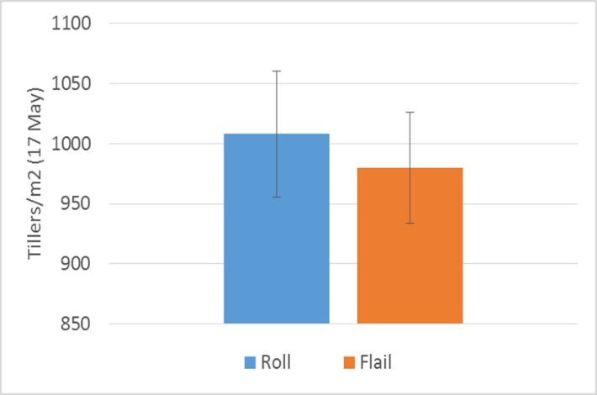
Figure A1. Tillers per m² measured in the barley crop post cover crop destruction in the rolled and flailed strips of Farmer A’s Field 1.

In Farmer A’s field 2 where different destruction methods were applied at right angles to different cover crops, there appeared to be more re-growth from the radish that had been flailed than where it had been crimped. There were also apparent differences between the species. In the following barley crop, it could be seen that there were no stalks of the crimped mustard/phacelia standing up but where the radish and early radish had been crimped, some old stalks were still standing.
When the following barley crop was established, the green area index (GAI; the m² of green canopy per m² of soil) was measured by taking a photo and using the online Canopy Assessment Tool to determine GAI. This analysis idicated that the GAI of the barley was greatest where it was following radish at a high seed rate (Figure A2), although since treatments weren’t replicated there may be an element of natural field variation affecting this.
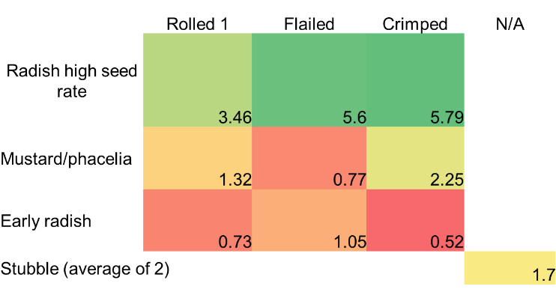
Figure A2. Green Area Indices (GAI) of barley following different cover crops destroyed using different methods.
Satellite imagery was taken on 7th May and NDVI results for fields 1 and 2 were determined, where red = low NDVI (indicating thinner crops) and blue = high NDVI (indicating thicker crops). In field 1 (Figure A3) there was a low NDVI area at the top of the field but there were no obvious differences between the 2 destruction method treatments which were running from top to bottom of that field. In field 2, the main difference appears to be between the cover-cropped area (square marked 2 in A3) which gave a higher NDVI in the following barley and the rest of the field which was left with stubble over winter.
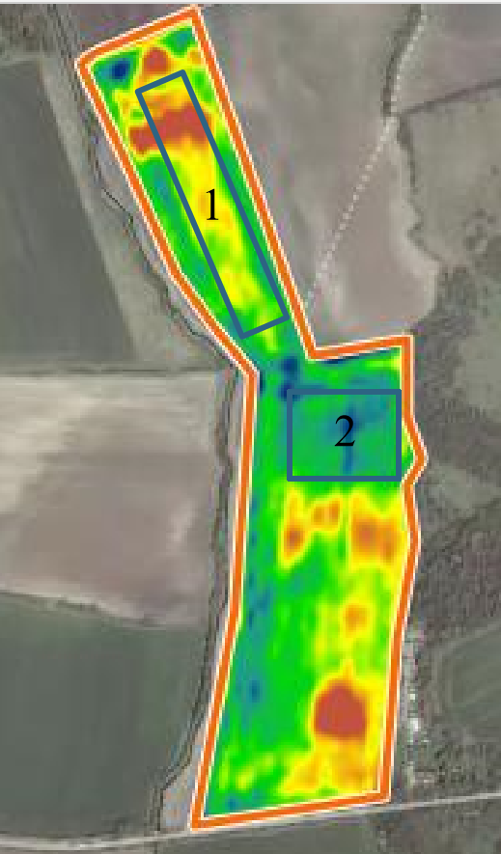
Figure A3. NDVI map showing Farmer A’s fields 1 and 2. Red indicates a thinner crop and blue indicates a thicker crop.
Farmer A submitted yield data from Field 2, and this could be analysed to test the differences between 3 destruction methods (rolled, flailed, crimped) on the yield of the following barley crop. Analysis showed there was no difference in yield when the rolled and flailed areas were examined. However, there was an indication that the crimped area led to a higher yield of the following crop than the flailed area.
Farmer B
In Farmer B’s field, after cover crop mixes A and B were destroyed using either glyphosate or liquid fertiliser, a spring linseed crop was established on 3rd May. An assessment of this crop was made on 31st May. It appeared that there was a good kill of both cover crop mixes from the glyphosate treatment, but that the fertiliser treatment killed Mix B more effectively than Mix A. A plant count (Figure B1), showed the destruction method of using liquid fertiliser led to higher plant populations in the following crop than using glyphosate, likely to be due to the increased amount of N in the soil. There was a higher plant population where Mix B had been killed by fertiliser than using the same method for Mix A, confirming the observation that Mix B had been killed more effectively by fertiliser than Mix A, allowing more plants of the following crop to establish. NB. All strips received same total nitrogen

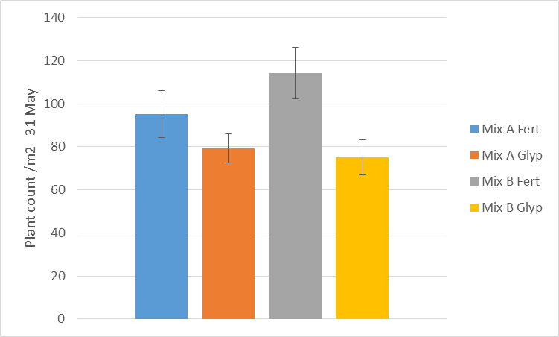
Figure B1. Plant counts of the linseed crop following cover crops Mix A or B destroyed using Glyphosate or liquid fertiliser.

No NDVI measurements were taken at this site.
Farmer C
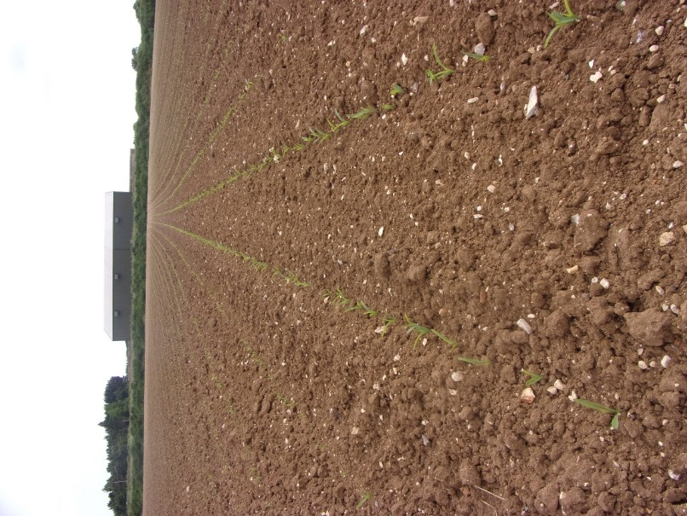
Farmer C planted maize after destroying the Mix A cover crop using either glyphosate or discing. The establishment of the maize was even across the two establishment methods with no oilseed radish root residue visible. The dry weather may have helped with the destruction.
Figure C1. Farmer C’s established maize crop following Cover crop mix A (right), with glyphosate destruction.
Satellite imagery was used to determine NDVI on 1st July (Figure C2). There were no obvious treatment differences across the field Similar results were found with Mix B in a second field with no significant effect on vegetation cover in early July from different cover crop destruction methods.

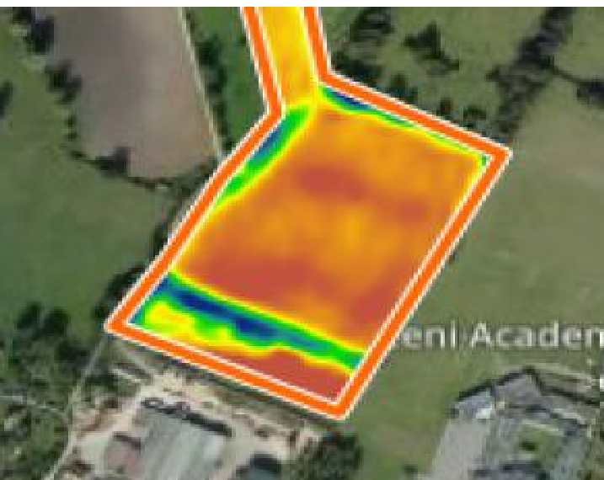
Figure C2. NDVI map of Farmer C’s field taken 1st July.
Discussion
2018 was a very difficult year to carry out these field trials due to the late spring followed by a hot dry spring/ summer. This affected the ability of some of the triallists to carry out their plans for the trial.
In the trials reported here, there appeared not to be any significant differences between mechanical cover crop destruction methods in the following crop. Although there appeared to be slightly more re-growth from the radish that had been flailed rather than crimped at Farmer A’s Field 2, this wasn’t evident from the GAI or NDVI data. However, there was some evidence that the crimped area may have led to slightly higher yields in the subsequent crop.
Where a chemical (glyphosate) method was compared to a mechanical one (discing), both methods appeared equally good at cover crop destruction and there were no differential effects on NDVI. Only where glyphosate was compared to liquid fertiliser as a destruction method were there any differences. Here the fertiliser treatment led to greater plant numbers in the subsequent crop with an interaction with cover crop mixture. Although the total amount of fertiliser applied to the crop was the same, the earlier available N from the destruction of the cover crops with liquid fertiliser is likely to have given an advantage to the newly-drilled crop.
There did appear to be some effect of cover crop species on the GAI of the subsequent crop where Radish (high seed rate), Mustard/phacelia and Early radish were compared. The Radish (high seed rate) appeared to lead to a higher GAI in the subsequent crop.
Overall, there seemed not to be any negative impact of cover crop destruction method on subsequent crop. However, all these farmer-led trials were of different designs and testing slightly different treatments. Therefore, it is not possible to come to any firm conclusions without further research.
The farmers involved in the field lab were as interested in learning more about the linking of cover crop mix, destruction method/timing and choice of the following crop as they were in the method of destruction.
Low temperature was useful for destruction of some cover crops such as mustard, where the combination of stem bruising and cold weather worked well to kill the plants. Crimping twice was more quickly effective than crimping once (due to the additional stem damage done) or flailing once for all cover crops.
5 Conclusions/Recommendations
This field lab has been encouraging in that no negative impacts on following crop establishment were found from the range of cover crop termination methods used on the three sites. However, more field trials are required to better understand the efficacy of different termination methods in different situations.
In addition, several learnings emerged from this trial which should assist in any future trials of cover crop termination methods on farm. These are set out below.
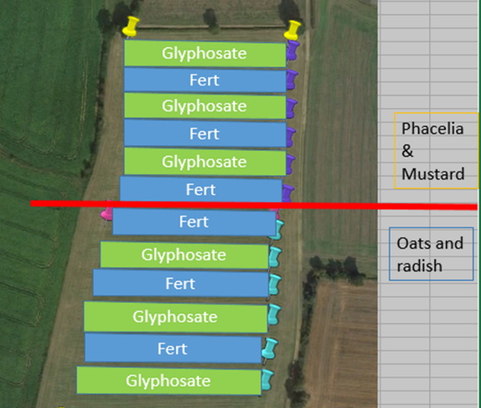
- A split field of cover crop mixtures rather than separate fields allows the comparison of destruction treatments between the cover crop mixes. This is more reliable than comparing destruction treatments between two separate fields with different cover crop mixes. See diagram to the right.

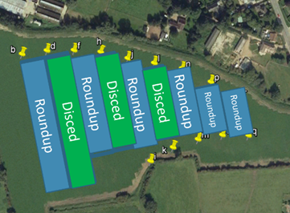
- Using at least three replicates of treatments, with sharp boundaries, allows for more accurate yield measurements and give greater certainty if a particular treatment influenced yield compared to the control treatment (stubble/glyphosate destruction). See diagram to the right.

6 Further reading
Case, P. (2017). EU allows petition calling for glyphosate ban, Farmers Weekly, http://www.fwi.co.uk/arable/eu-allows-petition-calling-for-glyphosate-ban.htm
Forcella, F. (2014). Short-and full-season soybean in stale seedbeds versus rolled-crimped winter rye mulch. Renewable Agriculture and Food Systems, 29(01), 92-99.
Holland, J. M. (2004). The environmental consequences of adopting conservation tillage in Europe: reviewing the evidence. Agriculture, Ecosystems & Environment, 103(1), 1-25.

Innovative Farmers is part of the Duchy Future Farming Programme, funded by The Prince of Wales’s Charitable Fund through the sales of Waitrose Duchy Organic products. The network is backed by a team from LEAF (Linking Environment and Farming), Innovation for Agriculture, the Organic Research Centre and the Soil Association

